1. /home/manderson113
2. The new folder csc3320 was created, from nothing to "csc3320"
3. pwd
4. mkdir lab2
5. cd lab2
6. '>' outputs the inputed text into the given filename.  
   Ctrl-D signals the end of the text stream, end of file
7. 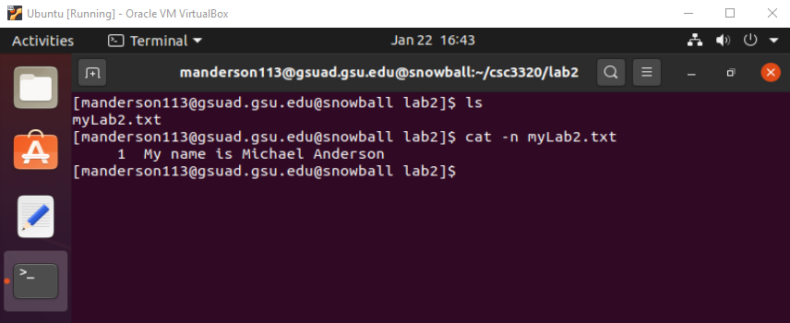
8. 